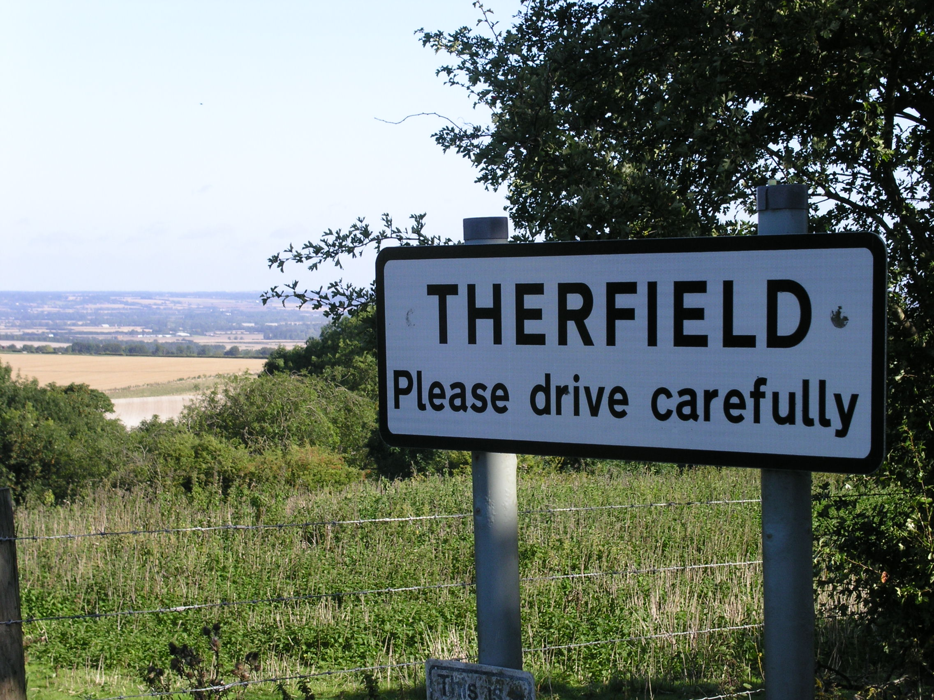  Therfield Traffic Questionnaire | Abstract  Therfield Parish Council is seeking your views on your safety from traffic in our village. We encourage you to fill in this brief questionnaire.  Therfield Parish Council

Introduction

Dear Resident of Therfield,

Your parish council is interested in your views on traffic safety and speed limits in the village of Therfield.
The topic was first broached at our Annual Parish Meeting in May. The feeling in that meeting was that the Parish Council should put out an informal survey to residents to collect their views on traffic safety in the village.

Please read the following information and complete our informal survey. It should not take more than a few minutes of your time and will be of enormous help in any future discussions with Hertfordshire County Council.

Background
Hertfordshire Vision:
You may have heard or read that Hertfordshire County Council introduced a new speed management strategy earlier this year. Their vision states:

“We want a Hertfordshire where:
- no one is killed or seriously injured on our roads
- everyone feels safe and confident travelling
— whether walking, wheeling, cycling, riding, driving or using public transport

We know that people make mistakes.

Our roads, speeds and behaviours should be managed so that when mistakes
happen, they do not lead to serious or fatal harm.”

Their new approach focuses on setting speed limits that are safe and appropriate for the place and the people using it.

Part of this strategy is to introduce 20mph speed limits on roads near schools, in residential areas, or those close to recreation areas. The aim is to create safer, calmer streets for residents, support children walking to school, and make it easier and safer for everyone to move around the area.

This is a long-term plan with towns and villages being consulted on their views prior to implementation.

Why this questionnaire?
Our own village, Therfield, is not yet on the list of potential areas for a speed limit change, however it might be possible to bring forward the formal consultation if sufficient support was shown by you, the residents of the village.

The village is seeing an increase in traffic levels from motorists passing through.

The introduction of 20mph limit does not mean that other traffic calming measures like speed humps, chicanes, or street lighting will also be required. If introduced it is likely that such a limit would replace the current 30mph zone.

Advantages:
Small increases/decreases in speed can make a big difference to whether someone is:
- able to stop in time;
- seriously injured;
- or survives.
Speed also affects how places feel:
- whether people feel safe walking on, next to, or crossing the road;
- whether children and older people can travel independently;
- whether communities feel calm or dominated by traffic.

Disadvantages
- Your journey through the village will take a few seconds longer;
- Impatient motorists may attempt reckless manoeuvres to overtake speed compliant drivers.

Statistics on fatality risk due to speed:
At 20 mph a car could stop in time to avoid a child running out three car-lengths in front of it. If the car does impact, it will have relatively low kinetic energy so the forces during impact are smaller. There is a 2.5% fatality risk at 20mph.
At 30mph the kinetic energy is more than double that of 20mph leading to a 20% fatality probability. This rises steeply to a 90% fatality probability for 40 mph, where the crash forces and damage are much higher due to kinetic energy being 4×greater than 20mph. The fatality probability exceeds 95% by 50mph and is a near certainty by 60mph

Questionnaire
To assess the overall views on traffic safety in the village, we have created a short questionnaire. We would appreciate your views.
When completed please return to Suffolk House – opposite the Fox & Duck pub. Alternatively, online responses can be emailed to roadsafety@therfieldparishcouncil.gov.uk.

Q 1: I feel safe walking or cycling in the village
Please tick one:
Strongly agree | Agree | Neutral | Disagree | Strongly Disagree

Q 2: Do you think speeding is an issue in the village?
Not at All | A minor problem | A moderate Problem | A serious problem | No opinion

Q 3: Do you have any traffic safety concerns in the village? If so, please tell us what and where they are.

Q 4: What do you think could be done to ease these concerns?

Q 5: Have you been involved in or witnessed a collision in the village? If so, please give brief details.

Q 6: Do you believe that a lower speed limit will help to improve your safety in the village.
Please tick one:
Strongly agree | Agree | Neutral | Disagree | Strongly Disagree

Q 7: Would you support the use of automated speed enforcement in the village
Please tick one:
Strongly agree | Agree | Neutral | Disagree | Strongly Disagree

Q 8: Would you be in favour of a 20mph speed limit in Therfield?
Please tick one:
Strongly agree | Agree | Neutral | Disagree | Strongly Disagree

Please explain briefly your response to the last question:

Q 9: Do you think a 20mph restriction, if introduced, should be limited to peak hours when the children are being taken to or from the school and pre-school.
Please tick one:
Should apply all the time | Only at school times | Don’t believe we need a 20mph limit

Q 10: Do you have any further suggestions on how to improve residents’ safety and to manage traffic passing through the village?

Without giving your full address, please tell us which road you live on (because different locations within the village may have different opinions).

Thank you for your time and opinion.
We will keep you informed of the results on our website and village newsletter.
Please return the form to Suffolk House, Police Row (opposite the Fox and Duck).
Alternatively, online responses can be emailed to roadsafety@therfieldparishcouncil.gov.uk.

